We are often asked in New College – can I get a job with an interdisciplinary degree? According to a First Destination Survey administered by UA’s Career Center, the answer is a resounding “yes.” Based on data from our May 2014 graduates, eighty-five percent of New College graduates were either employed or enrolled in a post-baccalaureate program (e.g., medical school, law school, or graduate school) six months after graduation.
What makes New College students so competitive? Simply put, the tools we equip our students with are what employers want. A New College graduate recently shared an editorial in Lagniappe Weekly (Mobile) written by Ken Robinson. He cites a 2013 survey of American businesses in which ninety-five percent of respondents said they wanted to hire college graduates “who can think clearly and solve problems and be able to translate their ideas with good oral and communication skills.” This is the essence of a liberal arts, interdisciplinary degree. In today’s “creative economy,” individuals must constantly relearn, retool, and remake themselves to be successful in the job market. Gone are the days when a person retires from the job he/she began fresh out of college.
As the late Steve Jobs noted, “It is in Apple’s DNA that technology alone is not enough. It’s technology married with liberal arts, married with the humanities, that yields us the result that makes our hearts sing.”
In this issue of the New College Connection we share stories of what makes our New College students’ hearts sing.

New College Connection
NC Students Win Awards | 2
NC Musicians | 2
Alumni notes | 2
Med School and Law School | 3
First-Hand Knowledge | 3
Where are they now? | 3
Scholarships | 4

New College May graduate Jason Arterburn will be studying this fall in Beijing at China’s top university, Peking University, thanks to the Harry S. Truman Scholarship Foundation. As a Truman Scholar, Jason will receive up to $30,000 for graduate study. In 2014, 655 candidates from 294 colleges and universities were nominated for the prestigious Truman Scholar award. Only fifty-nine were chosen. Jason was also the recipient of a Critical Language Scholarship from the U.S. Department of State and a David L. Boren Scholarship from the National Security Education Program, which funded Jason’s year-long study abroad program in China. This spring Jason was awarded the Algernon Sydney Sullivan Award recognizing excellence of character and service to humanity.

http://nc.as.ua.edu
1

2014-2015 Scholarship Recipients

Jason Arterburn: Truman Scholar, Humanitarian, Man about Asia

Congrats to Sue Keel, New College’s Student Records Specialist, who was recently awarded the 2015 Outstanding Staff Award

Inside this issue:

Celebrating the Success of New College Graduates
May 2015

Elliot Callaway (2015) won the ASCAP (American Society of Composers, Authors, and Publishers) Foundation “Sunlight of the Spirit Award.” Created by ASCAP president and awarding winning songwriter Paul Williams, the award is presented to an individual who is exemplary in recovery and in music creativity.” Elliot performed his original song at the Lincoln Center in New York City.
Logan Bowden, New College senior, was selected as the winner of the LARABAR Renola Remix Singer-Songwriter contest for his original song “On the Road.” Logan performed his song at the Gregory Alan Isakov concert at the Fillmore West in San Francisco in February.
Brent McCollough graduated on May 2 and the next week began touring with the Nashville-based band Koa. He will release his debut album “Mystery” at the end of May.
New College alum Ben Joseph (2010) will begin the MA program in ethnomusicology at the prestigious SOAS (School for Oriental and African Studies) in London in the fall.

Claire Cochran (2014) is the new Motorsport Event Coordinator for Circuit of the Americas. She will be coordinating and facilitating track rentals and helping out with the operations of all races.
Joe Barnett (1996) has recently turned his hobby of beekeeping into a business. Starting out with 56 hives, he, unfortunately, has suffered the same fate as all beekeepers - a decrease in hives due to the world-wide phenomenon of disappearing bees.
David Ward (1991) will retire as a colonel from the military in December after serving 24 years in the Army. He has focused his career on humanitarian and civil affairs work in such countries as Afghanistan, Romania, Haiti, and Columbia. David was the primary planner for the initial response to the tornado outbreak in Alabama on April 27, 2011.
Tell us what you are doing by completing “Alumni Notes” at http://nc.as.ua.edu/alumni-news/alumni-update-form/ or by joining the alumni group on Facebook at: https://www.facebook.com/groups/2200466832/

Alumni notes (featuring the cool things NC alums do)
Check out Logan Bowden: www.larabar.com/renola-remix
Mark Ortiz and Randy Arnold were both selected as recipients of the 2015 Randall Outstanding Research Award. Dr. Ellen Spears nominated Mark for his research entitled “What Dreams May Come: Toward a Radical Politics of Becoming in the Anthropocene Era.” Dr. Catherine Roach nominated Randy for his research entitled “Iconography of the Southeastern Ceremonial Complex: Tracing the Nono-myth of the Heroic Twins.” Both were honored at an awards luncheon on April 1, 2015.
Nichole Camille Corbett was selected for a 2015-16 Fulbright U.S. Student Award to Turkey. The Fulbright program is the flagship international educational exchange program of the United States. As a Fulbright student, Camille will represent the U.S. as a cultural ambassador, enhancing mutual understanding between Americans and the people of Turkey. Camille follows in the footsteps of New College faculty, Dr. Catherine Roach (2013-2014 Fulbright Endowed Chair at Leeds University) and Dr. Marysia Galbraith (a Visiting Fulbright Scholar in Poland this year).

2

Note-able Achievements for New College Musicians

New College Students Win Randall and Fulbright Awards

Harriet Jernigan (1993): “I graduated from Stanford with a PhD in German Studies and Applied Linguistics and have taught German, English Comp, ESL/EFL, and other courses since 1998. I developed Stanford's first standardized language placement test, worked as the first official translator for Bauhaus-Universität Weimar, and have lived abroad multiple times. I currently teach In the German department at UC Berkeley.”

Leigh Wright (2011):” I am living in New Orleans starting a marketing solutions firm. I work specifically with sustainable businesses in the travel and tourism industry. Our main goal is to provide companies the confidence of where and how they are spending their marketing dollars. I am also involved with a host of start-ups in this area. My current project is a train from New Orleans to Austin for SXSW 2015 for entrepreneurs, politicians, and investors to have talks.” about start-ups in Louisiana.”

Tiffany Lopez (2005): “I live in Raleigh, and I’m a research librarian for the largest litigation firm in the Triangle area. I’m currently serving as President of the North Carolina chapter of the Special Libraries Association.”

Share your story: nadams@ua.edu
“This is it. This is what it’s all about.” These were the words I heard from Anthony Braxton as he walked onto stage for his first ever Solo Saxophone performance in Alabama. This coming from an NEA Jazz Master and MacArthur “Genius Award” Fellow who has recorded over 100 albums. The performance was one of seven events planned by our
Concert Series Management seminar (taught by Holland Hopson) in collaboration with the Sonic Frontiers concert series. Our class gained real world experience in all aspects of concert series management, including program planning, budgeting, marketing, merchandising, hospitality, documentation and logistics.

This class truly resonated
with New College’s approach to instruction and proved to be a very beneficial learning experience. As students, it was a rewarding and unforgettable experience to be part of the Anthony Braxton residency at UA.

Students Gain First-Hand Experience in Managing Concerts (by Pete Blankenship, ‘16)

Where are they now?
This May’s graduating class has an impressive number of students starting either med school or law school in the fall. Future doctors include Laura Freeman, a Blackburn Fellow and UA’s Most Outstanding Senior, and Amie Lemley, who delivered the commencement address at the New College graduation ceremony, will be attending UAB’s medical school. Katie Jernigan, a Blackburn Fellow, will be attending Texas A & M’s med school, and Alison Adams, a hospice volunteer, will be studying medicine at the Alabama College of Osteopathic Medicine.
Attorneys to-be include Mary Caroline May, a Walker County intern and Sustained Dialogue moderator, who will attend the University of Virginia. Giuliano Godorecci, whose depth study focused on music and technology, will be attending UA. And Aubrey Edkins, who clerked at a law office in Toulouse, France, will study law at Southern Methodist University.
In other law school news, Lin Wang (2014) will begin Harvard this fall. She will be in good company with Olivia Bensinger, last year’s New College commencement speaker.

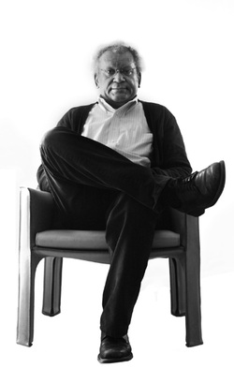

Heading to Med School and Law School
3

Congrats to May New College Graduates
B.A.
Amy Ackerman, Camden Adrian, Jason Arterburn, Dani Beach, Eugene Berry, Elliott Callaway, Camille Corbett, Aubrey Edkins, Jessica Edmundson, Laura Freeman, Giuliano Godorecci, Josh Gresham, Jessa Hudson, Michael Kearney, Julia Kolb, Dillon Lee, Mary Caroline May, Brent McCollough, Derek O’Quinn, Mark Ortiz, Alex Robinson, Theresa Sprain, Sarah Laura Thigpen, Forrest Thomas, Mary Wills, Corey Worman

B.S.
Alison Adams, Sloane Arogeti, Mackenzie Branco, Emily Collum, Katie Jernigan, Amie Lemley, Sarah Steeley

(Bold indicates students graduating with the highest honor – summa cum laude)

4
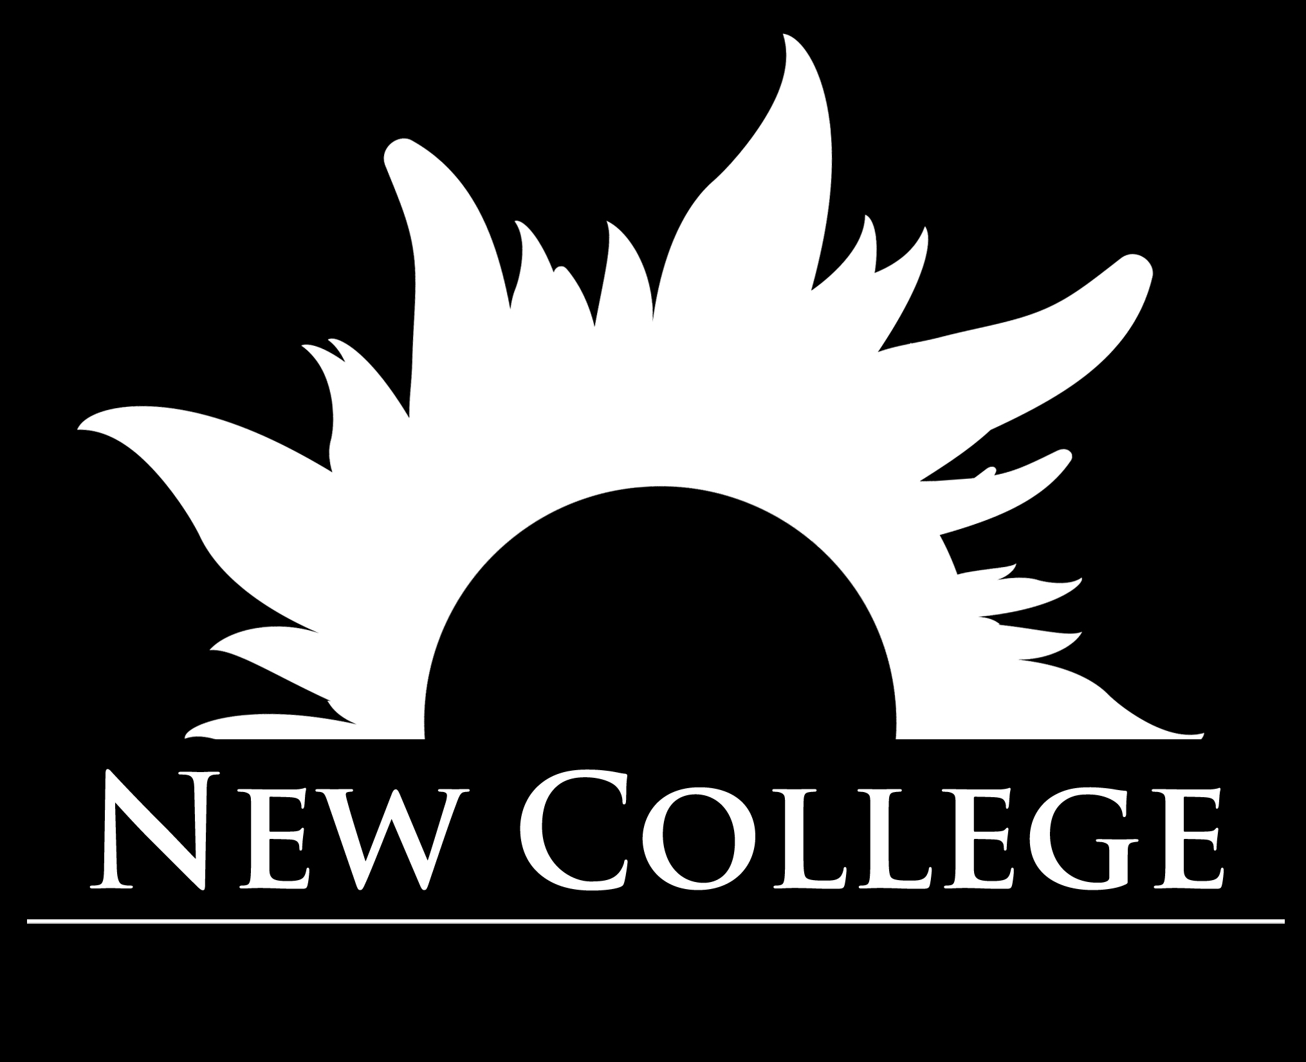

Hugh Holloway Endowed Scholarship Hannah Wright and Katie Jernigan
S.J. Senter Memorial Scholarship Aubrey Edkins, Hope Chandler, Josh Gresham
Bernard and Alma Weber Scholarship Clay Smilie, Ben McGowan, Caroline Pilot
Samuel Thomas Barnes IV Memorial Scholarship Cameron Lyons and Emma Smith
B. Franklin and Ophelia Watson Scholarhsip Mark Ortiz, Margaret Wilbourne, Julie Gyurgyik
Ann & Neal Berte Scholarship Demetrius Edwards, Kristin Faulkner, Forest Hooten,
Sara Johns, Caitlin McMahon, Julia Quan, Pada Schultz
Jerry Rosenberg Scholarship Mary Caroline May and Katy Turner
Suzanne Younger Award Katie Gunderson, Josh Harvey, Erin Williams
Jeff Levitetz Scholarship Doss Cleveland, Max Dolensky, Nick Gray, Forest Hooten,
Sara Johns, Brent McCollough, Caroline Pilot, James Rantzow, Preston Thompson
Dean Bernie Sloan Spirit of New College Award Randy Arnold
Fran Geddes Outstanding Service to New College Amy Ackerman

Are you interested in contributing to the Bing Blewett Endowed Scholarship fund? Call Kathy Yarbrough (205-348-0696) for more information about how to give.

